Final Milestone Project Report

Title:

Fake News Detection and Verification Tool

Student Name : Arya Nandini
Mentor Name : V. Manjuladevi
Student Email : myselfaryanandini@gmail.com
College : Vivekananda Global University
INTRODUCTION

The rapid growth of digital communication platforms has fundamentally changed how information is created, shared, and consumed. News is no longer limited to traditional media outlets; instead, it spreads instantly through social media, blogs, and online news portals. While this has improved access to information, it has also led to the uncontrolled spread of fake news. Fake news refers to false, misleading, or fabricated information presented as legitimate news with the intent to deceive readers.
The impact of fake news is significant, as it can influence public opinion, disrupt social harmony, and affect political and economic decisions. Manual verification of news content is time-consuming and impractical due to the massive volume of information generated daily. As a result, automated fake news detection systems have become increasingly important.
Traditional fake news detection approaches often rely on statistical machine learning techniques and feature extraction methods such as Bag of Words. Although effective in limited scenarios, these methods struggle to understand context, sarcasm, and evolving misinformation patterns. To overcome these challenges, this project adopts a Large Language Model (LLM)-based approach using Google Gemini. By leveraging semantic and contextual understanding, the proposed system can analyze news content more effectively and provide reliable authenticity verification.

PROJECT STATEMENT
The primary goal of this project is to design and implement an intelligent Fake News Detection and Verification Tool that can automatically analyse and verify the authenticity of news articles. The system aims to classify news content as Fake, Suspicious, or Reliable using semantic and contextual reasoning rather than traditional machine learning classification techniques.
The project focuses on eliminating the limitations of feature-based models by directly processing raw news text through an LLM-based analysis pipeline. The system is developed as a web application using the Flask framework and integrates Google Gemini to perform deep contextual evaluation. This approach ensures improved accuracy, scalability, and adaptability to real-world news verification scenarios.

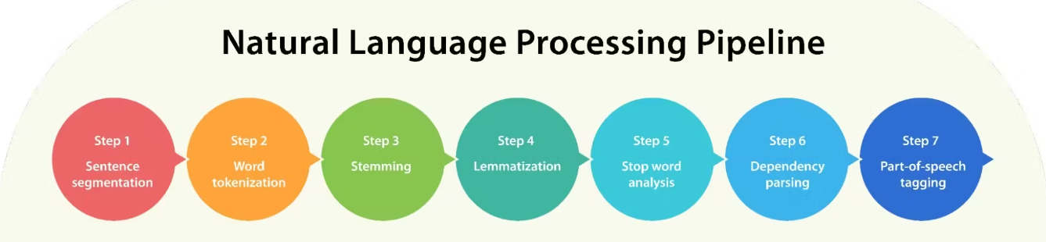

Key Outcomes
The successful implementation of this project achieves the following key outcomes:
- Development of an automated fake news detection system capable of real-time analysis.
- Accurate classification of news content into Fake, Suspicious, or Reliable categories.
- Utilization of semantic understanding for contextual analysis.
- The system provides a confidence score indicating the reliability of the classification.
- Implementation of a user-friendly web interface for news verification.
- Secure JWT user authentication and personalized analysis history tracking.
- The system utilizes a pre-trained Large Language Model (Google Gemini) to analyze news content and determine its credibility.
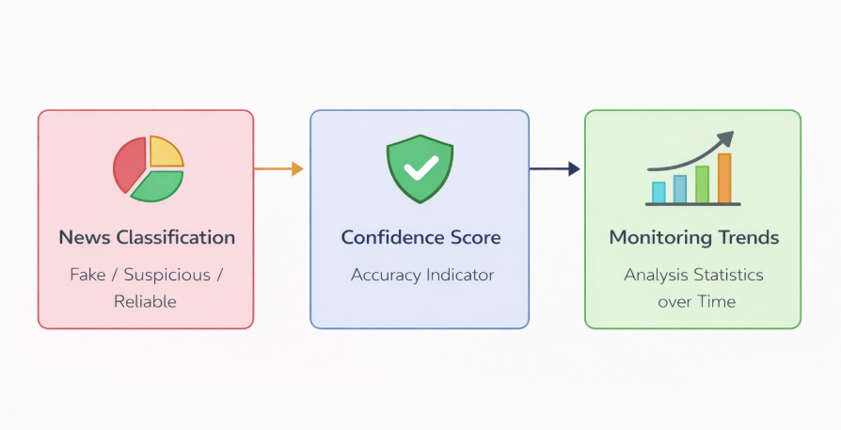
- Scalable architecture suitable for real-world deployment.
Figure : Key Outcomes of Fake News Verification and Detection Tool
MODULES TO BE IMPLEMENTED
1. User Interface Module
This module provides the frontend interface through which users interact with the system. Users can input news content for verification, view classification results, and access their analysis history.
2. Authentication Module
The authentication module handles user registration, login, logout, and session management. It ensures that only authorized users can access personalized features such as analysis history.
3. Input Validation and Preprocessing Module
This module validates user input to ensure correctness and safety. Basic normalization and formatting are performed before preparing the input for semantic analysis.
4. LLM-Based Analysis Module
This core module communicates with the Google Gemini API. It sends structured prompts containing the news content and receives semantic analysis results based on contextual reasoning.
5. Classification and Confidence Scoring Module
Based on the Gemini response, this module assigns one of the three classifications—Fake, Suspicious, or Reliable—and computes a confidence score representing prediction reliability.
6. Database Management Module
This module stores user information and analysis records. It supports efficient retrieval of historical data and enables analytics on user activity.

SYSTEM ARCHITECTURE
The system follows a client–server architecture integrated with an external AI service.

Architecture Description
Users interact with the system via a web browser. The frontend sends requests to the Flask backend, which performs input validation and constructs prompts for the Gemini LLM. Gemini performs semantic and contextual analysis and returns classification results with confidence scores. These results are stored in the database and displayed to the user.

Architecture Flow
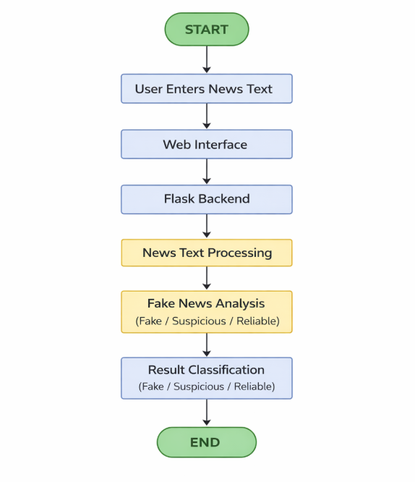
The diagram illustrates the workflow of the proposed system, where user-provided news content is processed through a Flask-based web application and analyzed using the Google Gemini Large Language Model. The system performs semantic and contextual verification to classify news as Fake, Suspicious, or Reliable and stores the result along with a confidence score in the database before displaying it to the user.

DATABASE SCHEMA
The system uses a relational database managed using SQLAlchemy ORM.
User Table
- User ID (Primary Key)
- Username
- Email
- Password (Hashed)
Analysis Table
- Analysis ID (Primary Key)
- News Text
- Classification Result
- Confidence Score
- User ID (Foreign Key)
- Timestamp
Relationship
One user can perform multiple news analyses, establishing a one-to-many relationship between the User and Analysis tables. Below explains User → Multiple Analyses relationship clearly.
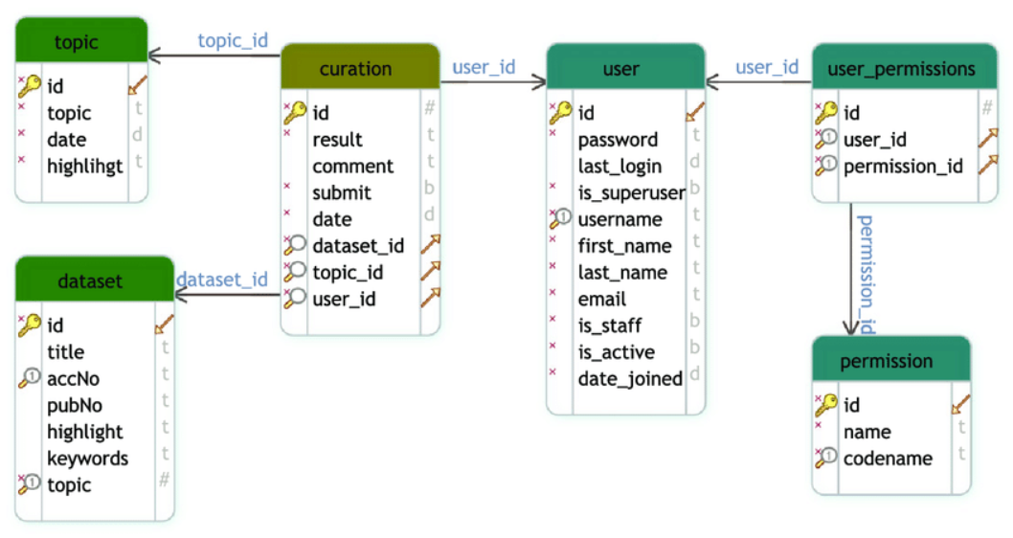

SAMPLE OUTPUT
The sample output demonstrates the system’s ability to verify news authenticity effectively.
Input
A news article or headline entered by the user through the web interface.
Output
- Classification Result: Fake / Suspicious / Reliable
- Confidence Score: Percentage indicating reliability
- Timestamp of analysis
The output is displayed immediately on the screen and stored in the user’s analysis history for future reference.
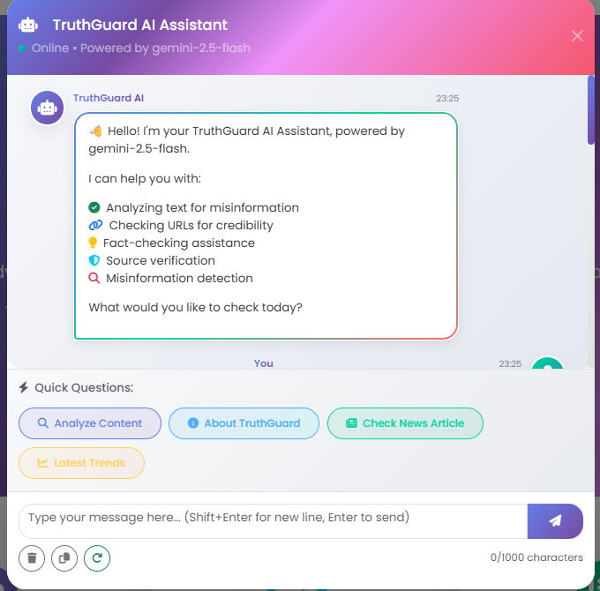
Image: Truthguard AI Chatbot

- Classification Result: Fake / Suspicious / Reliable
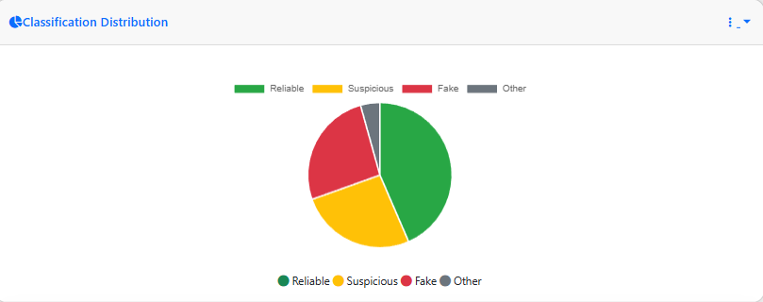
Classification Distribution
The pie chart illustrates the overall distribution of analyzed news articles across different categories. Each segment represents the proportion of news classified as Reliable, Suspicious, Fake, and Other. This visualization helps in understanding the credibility trends of analyzed news content and provides a quick summary of system predictions over time.
- Reliable: News content verified as trustworthy
- Suspicious: News content requiring further verification
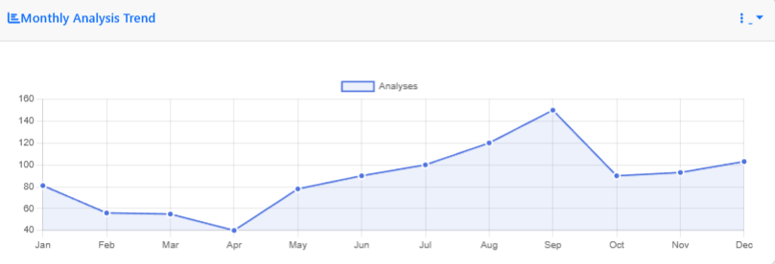
- Fake: News content identified as misleading or false

Monthly Analysis Trend
The line graph depicts the monthly trend of news analyses performed by the system. It shows how the number of verifications varies over different months, indicating system usage patterns and engagement levels. Peaks in the graph suggest increased verification activity, which may correspond to periods of high news circulation or significant events.
Admin Dashboard and Analysis Output
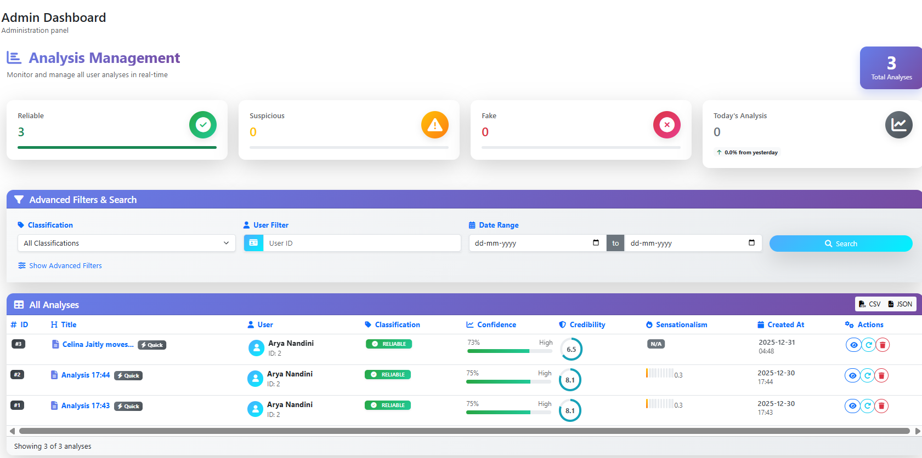 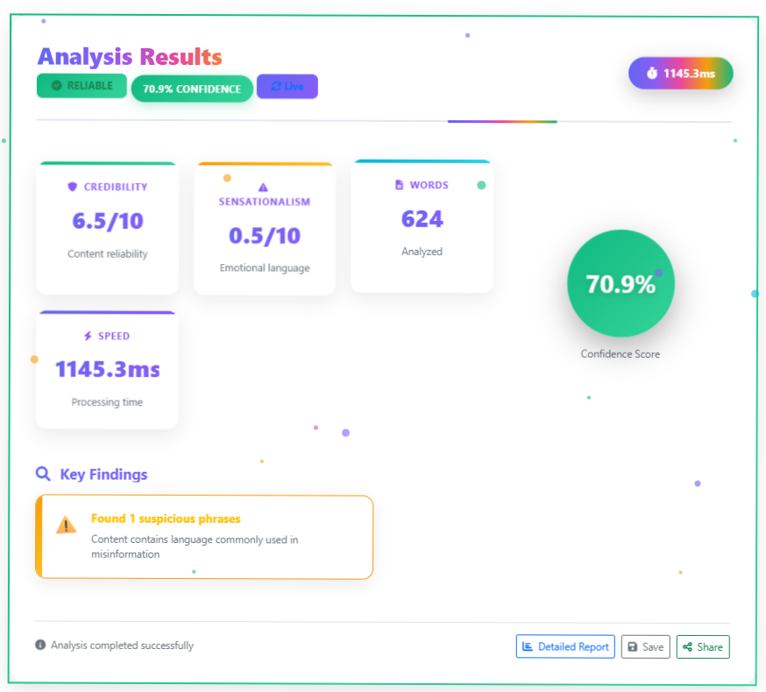
The figure illustrates the Admin Dashboard and Analysis Results of the Fake News Detection and Verification Tool. The dashboard enables administrators to monitor total analyses, classification status (Reliable, Suspicious, Fake), and user activity in real time. The detailed analysis section displays the classification result along with confidence score, credibility level, sensationalism score, and processing time, providing a comprehensive view of news verification outcomes.

FUTURE SCOPE
1. Multi-Language Fake News Detection
The system can be extended to support multiple languages by leveraging multilingual capabilities of large language models. This will help detect fake news across different regions and cultures.
2. Real-Time News Verification
Integration with live news APIs and social media feeds can enable real-time analysis of trending news, making the system more practical for journalists and fact-checking organizations.
3. Browser Extension Integration
A browser extension can be developed to allow users to instantly verify news articles while browsing the internet, improving usability and accessibility.
4. Image and Video Misinformation Detection
Future versions can include detection of fake images and videos (deepfakes) by integrating computer vision models alongside the language model.
5. Advanced Analytics Dashboard
An analytics dashboard can be added to visualize trends such as frequently flagged fake news topics, confidence score distribution, and user activity insights.
6. Model Optimization and Fine-Tuning
The system can be further enhanced by fine-tuning the LLM or combining it with domain-specific fact-checking datasets to improve accuracy and reliability.

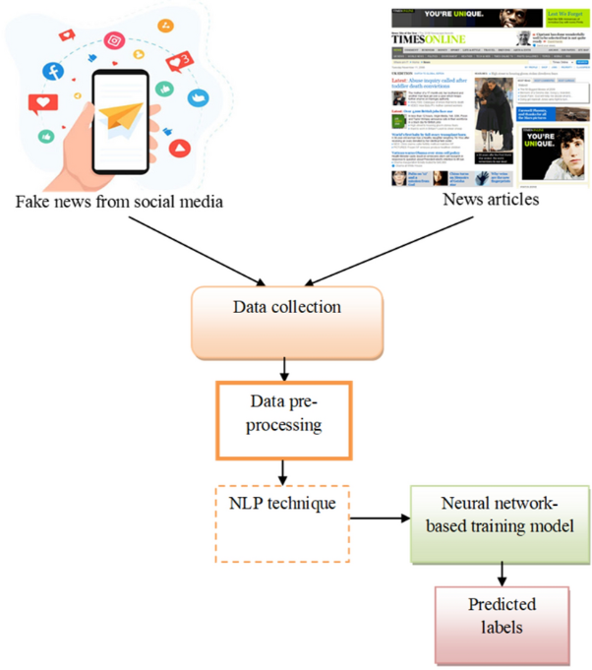
System Workflow Description
The diagram represents the overall workflow of the Fake News Detection and Verification Tool. News data is collected from sources such as social media platforms and online news articles. The collected data is then preprocessed to remove noise and normalize the text for analysis.
Natural Language Processing (NLP) techniques are applied to understand the contextual meaning of the news content. The processed data is analyzed using an AI-based model, which evaluates the authenticity of the information. Finally, the system generates predicted labels, classifying the news as Fake, Suspicious, or Reliable.

CONCLUSION
This project successfully presents a Fake News Detection and Verification Tool based on LLM-driven semantic analysis. By leveraging Google Gemini, the system overcomes the limitations of traditional machine learning approaches and provides accurate, context-aware verification of news content. The modular architecture, scalable design, and user-friendly interface make the system suitable for real-world applications. The project highlights the effectiveness of LLM-based reasoning in combating misinformation and contributes toward building more trustworthy digital information ecosystems.

